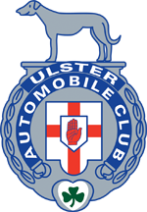
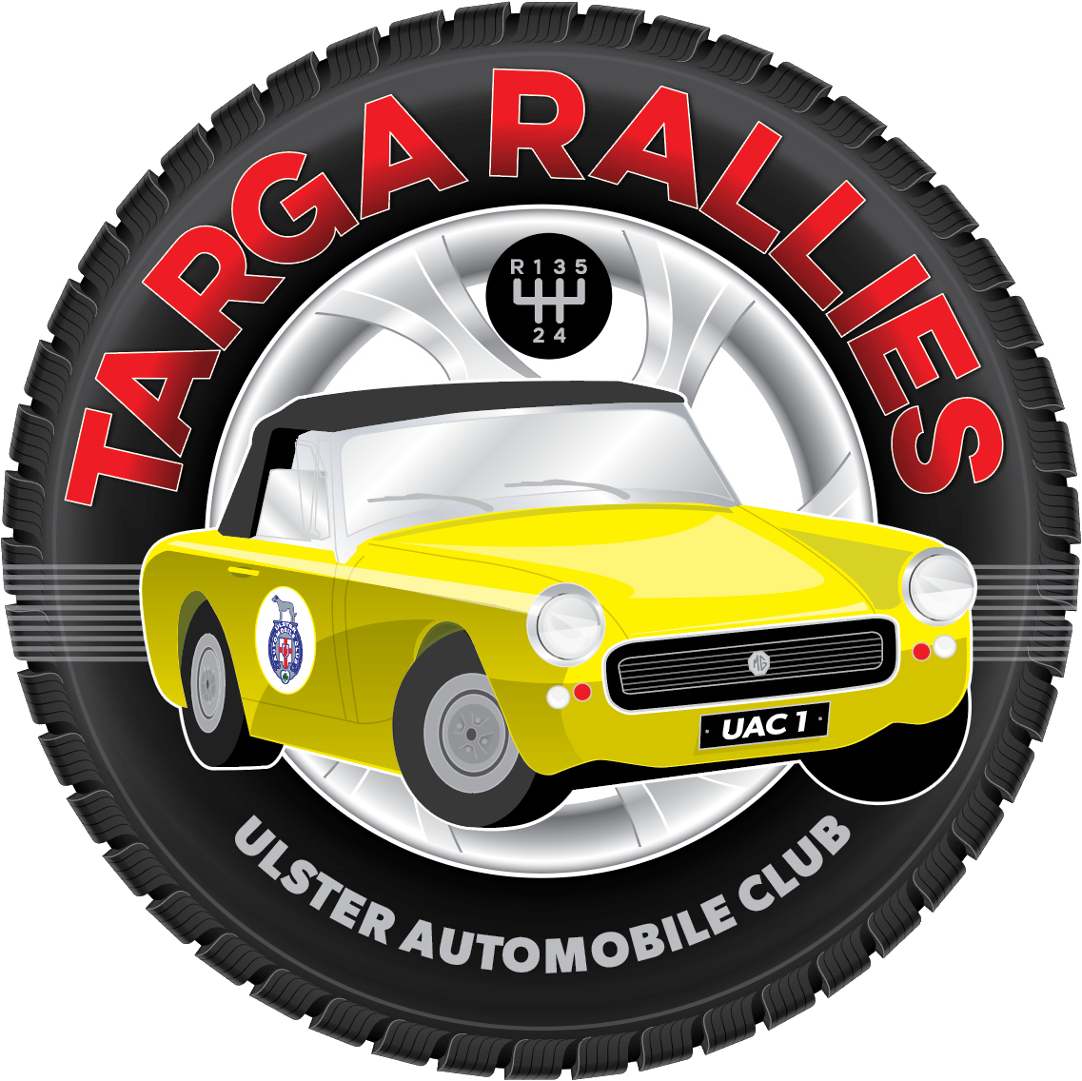
Ulster Automobile Club Ltd
It’s Not the Boxing Day Rally
27th December 2021
Supplementary Regulations

- The UAC Ltd will organise a Clubman’s Permit Production Car Autotest on Monday 27 December 2021, at Kirkistown Racing Circuit, 130 Rubane Road, Kircubbin, BT22 1AU.
- The meeting will be held under the General Regulations of Motorsport UK,
(incorporating the provisions of the International Sporting code of the FIA), these Supplementary Regulations and any written instructions that the organising club may issue for the event.
- MSA permit no. TBA Production Car Autotest, has been received, and as such all cars MUST carry 2 persons.
- Passengers must hold a current RTA licence, and must have autotest experience if the driver does not.
- Both entrants MUST hold a 2021 Motorsport UK Clubman’s Licence (minimum). This licence is free and can be applied for via the Motorsport UK website.
- The event is open to all fully elected members of the UAC. All competitors must hold a valid 2022 membership card.
- Scrutineering will be by self declaration.
- Tests will be able to be walked from 8 – 9am on the morning of the event.
- First car starts 9.30am, with up to 3 runs at up to 11 tests, timeand weather permitting.
All tests may not count towards final results. Drivers briefing will start at 9.15 sharp.
ALL COMPETITORS MUST ATTEND.
- The event shall consist of classes as follows –
Class 1 Classic Cars, Pre ‘85
Class 2 Front Wheel Drive Cars
Class 3 Rear Wheel Drive Cars
Class 4 Juniors
Running order within each classes will be organised at the Club’s discretion.
- The entry list opens at 7pm on Wednesday 1st December 2021. Entries must be made via Rallyscore at www.rallyscore.net. Entries will not be accepted until paid in full, and Club membership has been approved.
- The entry fee is £80, to include 2 x breakfast vouchers per car. Dual entries are permitted.
- The maximum entry for the meeting is 85. The minimum is 70. Should the minimum figure not be reached the organisers have the right to cancel the event.
- WITHDRAWN ENTRIES WILL INCUR AN ADMINISTRATION FEE OF £5, up to Monday 20 December, after which the entry fee will be forfeited in full, unless a reserve can be found. Forfeited entry fees will be donated to the Club’s chosen charity.
- Cars must be a production car capable of passing MOT, but do not need to betaxed or hold a current MOT.

- Officials are -
Event Steward Wilson Carson
Clerk of the Course Wallace McKee
Deputy CoC Roger Fynn
Event Secretary Lucinda McKee
Assistant Secretary Sharon Carson
Results Stopastride Live Timing
Scrutineer Graeme Stewart
Chief Marshal Tom Allison
- Provisional results will be published as soon as possible following the end of the event, the final results will be posted on the Club and ANICC websites.
- Any protest must be lodged in accordance with Motorsport UK Regulations C5.1 – 5.7.
- Competitors will receive an email with final instructions, regarding the test diagrams which will be available via the sportity app (https://sportity.com/app) and may be on the Club Facebook Page, and website.
- Timing will be by stopwatch to the nearest 0.10 second.
- The starting signal will be verbal.
- The order of attempting tests will be as instructed at the drivers briefing.
- Competitors must run in order, unless permission is granted by the CoC, failure to comply may result in a 30 second penalty.
- If a car breaks down, and is repaired the driver may re-join at the end of the group.
- Practising will not be allowed and may result in disqualification. THERE WILL BE NO WALKING OF TESTS ONCE THE EVENT STARTS.
- Penalties will be as follows as per the 2021 Motorsports UK Yearbook table M7 on page 224:
  - Pylons, striking any barrier - 5 seconds per offence
  - Lines, failure to stop astride a line as requested - 5 seconds per offence
  - Not performing test correctly - fail.
NB fail = fastest time in class, on that test plus 20 seconds.
- Juniors – Must be over 14 years of age. Cars must be a standard production car, have all 4 seats fitted and be, by definition, a touring car. The car must not exceed 1400cc. One passenger holding a full RTA MUST accompany juniors.
- Competitors will be able to download a timecard for their own use from the sportity app https://sportity.com/app
- Competitors are reminded of noise limits – Motorsport UK regulations J5.17.1-8 – J5.18.1-11.
- In the event of a tie, total penalties accrued by each competitor will be compared after the 1st visit to each test. If this fails to resolve the tie then the total penalties accrued on the 2nd visit will be considered, and so on until the tie is resolved.
- In accordance with Motorsport UK guidelines Sharon Carson is the Club’s Safeguarding Officer, who can be contacted if required on 07989 849797
- Judges of Fact shall be all Officials named above, all signed on marshals, plus anyone nominated by the CoC.
- Tyres from lists 1b & 1c are NOT permitted . All other road going E marked tyres are permitted.

All queries should be addressed to the Event Secretary, Lucinda McKee on 07872 059564, or by email enteruac@yahoo.com

All Covid regulations in place at the date of the event will be strictly adhered to. This includes passports, LFT, mask wearing, hand sanitising and socially distancing.

